Lab 1 – Requirements Engineering & UML Use-Case Modelling
Varun Rao | PES1UG24CS520 | Section 5-I
Problem Statement #30 — Airport Lost Luggage Claim & Tracking Portal
Domain: Smart Cities, Transport & Logistics

1. Problem Context
Airports lose track of checked bags fairly often — a missed scan at a transfer point, a mis-routed tag, a late connection, or just a manual handling slip is enough to break the trail. Right now ground staff deal with this by cross-checking paper logs or separate terminal systems by hand, which is slow, and passengers have no visibility into what's happening to their bag.
This portal fixes that by giving passengers a way to report a missing bag and track it, and giving Baggage Service Agents one place to see scan events from every connected terminal, so they can match a claim to a bag and push it to compensation if it isn't found in time.
Actors: Passenger, Baggage Service Agent

2. Functional Requirements
Five requirements (FR-001–FR-005), built by walking through the recovery journey: a passenger reports a bag, the system tries to match it against scan data, an agent works the case, and the passenger gets kept in the loop. FR-001 was the given sample; FR-002–FR-005 were written for this submission.
ID | Requirement | Priority | Why it matters
FR-001 | Cross-check passenger lost-baggage reports against unrouted scan logs from all terminals. | High | Core recovery mechanism; without it agents search logs manually.
FR-002 | Let a passenger file a claim with flight details, bag description, and contact info. | High | Entry point of the whole workflow.
FR-003 | Give every claim a unique reference number the passenger can use to check status. | High | Lets passengers self-serve instead of calling the airline.
FR-004 | Let a Baggage Service Agent update claim status and log the change in an audit trail. | Medium | Needed for accountability and dispute resolution.
FR-005 | Notify the passenger by email/SMS whenever status changes or the bag is found. | Medium | Cuts down anxiety and manual status-check calls.

3. Non-Functional Requirements
NFR-001 was the given sample. NFR-002 was added to cover availability and usability, since baggage loss can happen at any hour to a passenger who's never used the portal before.
ID | Requirement | Priority
NFR-001 | The baggage-tracking timeline API must return full multi-leg scan history in under 200 ms. | High
NFR-002 | The portal should stay up 24/7 at 99.9% uptime, and a first-time user should be able to file a claim or check status in under 3 minutes. | Medium

4. UML Use-Case Diagram
The diagram covers both actors and the main use cases. «include» connects File Lost Baggage Claim to Verify Passenger Identity, since identity is always checked during filing. «extend» connects Send Delay Notification to Track Baggage Status, since a notification only fires if a delay is actually detected — not on every status check.
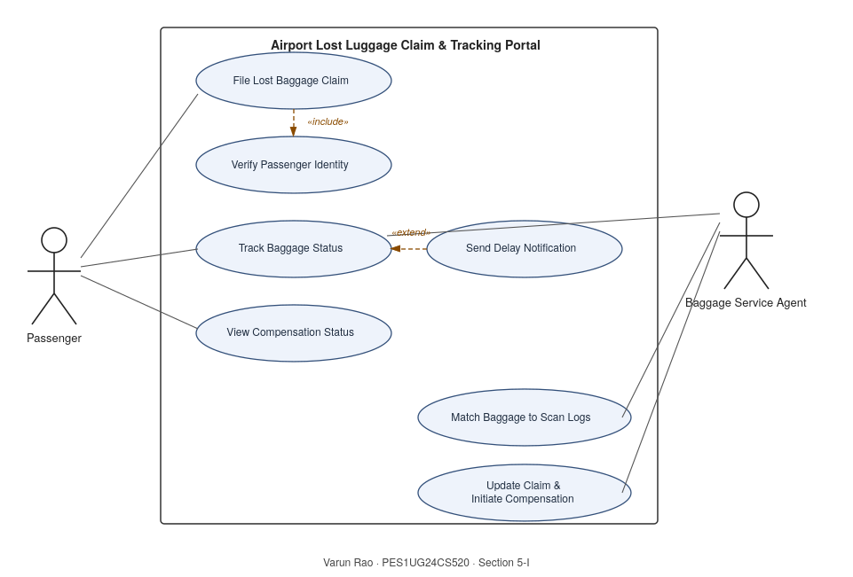

5. Use-Case Flow Specification
File Lost Baggage Claim
Actor: Passenger (primary), with Verify Passenger Identity included as part of the flow.
Preconditions
• The passenger's flight has landed and baggage claim has closed without their bag appearing.
• The passenger has their boarding pass / booking reference and original bag tag number.
Postconditions
• A claim record exists with a unique reference number, status "Under Investigation", and is queued for matching against scan logs.
• The passenger has received the claim reference number.
Main Success Scenario
1. Passenger opens the portal and selects "File Lost Baggage Claim".
2. System asks for booking reference and last name, then runs Verify Passenger Identity («include»).
3. Passenger identity is confirmed against airline booking records.
4. Passenger enters flight details, bag description, and contact info.
5. Passenger submits the claim.
6. System validates mandatory fields and generates a unique claim reference number.
7. System sets status to "Under Investigation" and queues it for matching (FR-001).
8. System shows the reference number to the passenger and confirms by email.
Alternate Flow — Identity Cannot Be Verified
3a. At step 3, the booking reference and last name don't match any record.
3a.1. System shows an error and asks the passenger to re-enter details.
3a.2. After three failed attempts, the system suspends the online flow and directs the passenger to the airport baggage desk with a reference number for in-person verification.
3a.3. Use case ends without a claim being created.
Note: this document covers the requirements table and use-case flow spec; the editable UML diagram source is included alongside this file.

